Jertrude Dimaano INM 420 SAA Part 2 Self-Learning
1. Did you achieve your goal? Was it easier or harder than expected?
Yes, I successfully achieved my goal of learning the Bulma CSS framework by building a responsive café website called Sip & Stay. The final website includes a navigation bar, hero section, menu layout using cards, an about section, and a footer. These components were implemented using Bulma’s layout system along with custom CSS for styling.
The process was more challenging than expected, particularly in refining layout details and ensuring responsiveness across different screen sizes. While Bulma is beginner-friendly and easy to start with, I realized that effectively combining its classes and achieving a clean, balanced design requires practice and experimentation. Overall, the experience helped me better understand how to use a framework in a practical project.
2. If it didn’t work, why not? What happened? What resources did you use? What did you learn from it not working?
The project was mostly successful, but I encountered a few challenges during development. One specific issue occurred in the menu section when using Bulma’s card component. There was an unwanted white gap between the image and the card content, which affected the visual consistency of the layout. This happened because the image sizing and container behavior were not properly controlled.
Although Bulma provided the structural layout for the card component, it did not automatically manage how images fit within the container. To resolve this, I applied custom CSS by setting a fixed height for the image container, using object-fit: cover, and applying overflow: hidden. These adjustments ensured that the images filled the space correctly without distortion or gaps.
To solve this issue, I referred to the Bulma documentation and experimented directly in my code through trial and error. This process helped me understand that while Bulma provides a strong structural foundation through components such as navbar, columns, card, and hero, developers are still responsible for handling detailed styling and layout behavior using CSS.
I also learned that Bulma is built on a Flexbox-based layout system, which allows for flexible alignment and responsive design across different screen sizes. In addition, I implemented a small JavaScript function to toggle the mobile navigation menu. This helped me understand that Bulma is a CSS-only framework and relies on developers to add interactivity when needed.
Overall, this challenge improved my problem-solving skills and deepened my understanding of how frameworks and custom CSS work together.
3. What would you do differently next time?
If I were to improve this project in the future, I would explore more advanced Bulma features such as form components, modifiers, and deeper customization options. I would also continue improving my CSS skills to better control layout, spacing, and visual details from the beginning.
In future projects, I aim to combine framework knowledge with stronger planning and CSS control to create more efficient and scalable designs. Overall, this project increased my confidence in learning a new framework independently and applying it in a real-world context.
Navbar & Hero Section
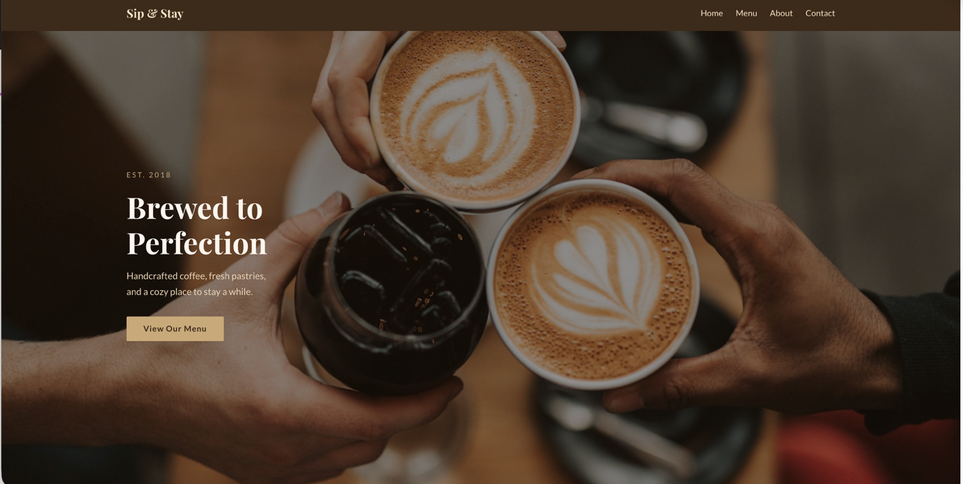
Figure 1. Navigation bar and hero section using Bulma components with custom CSS styling and
background image.
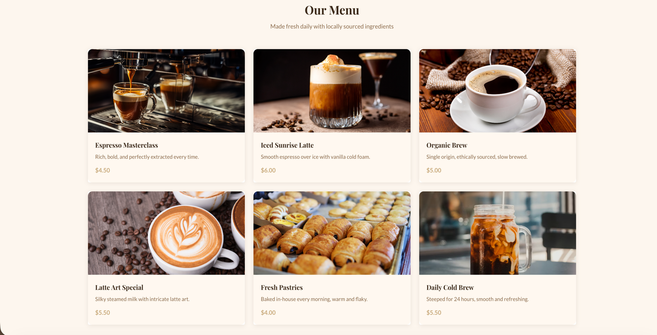

Figure 2. Menu section using Bulma’s columns and card components for a responsive layout.

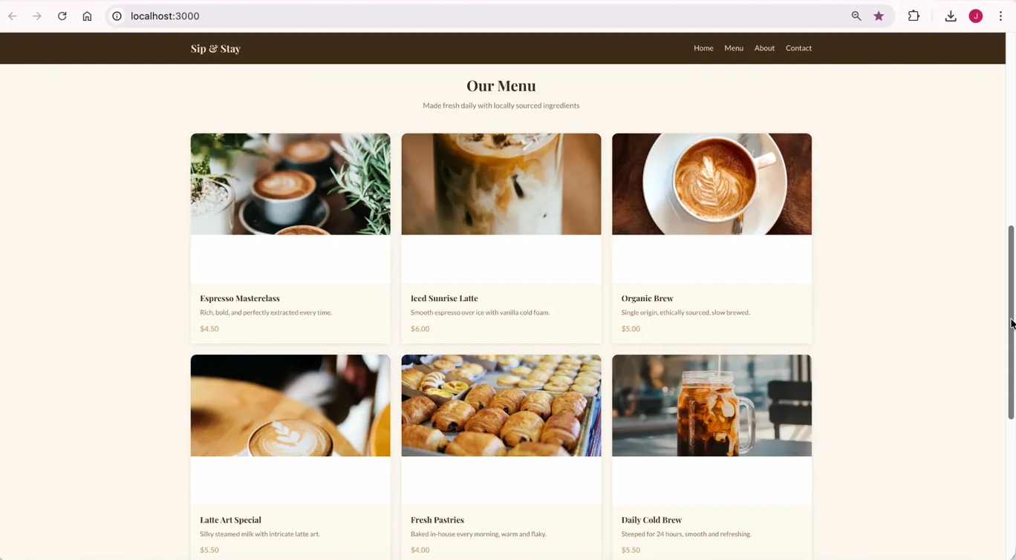
Figure 3. Initial layout issue showing unwanted spacing between the image and the card content.

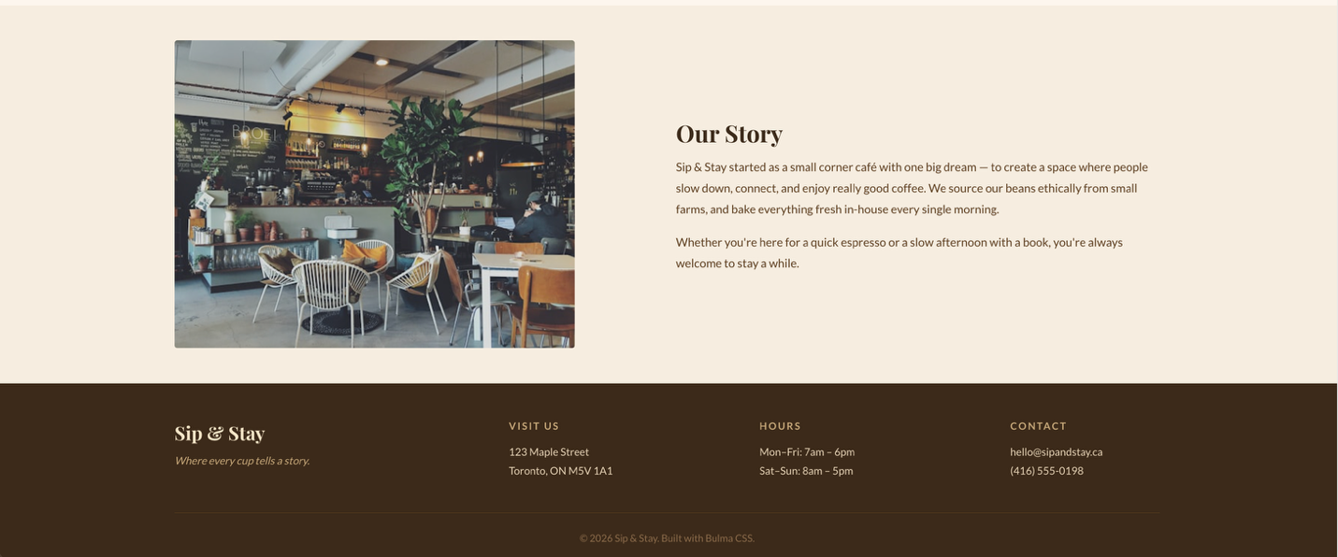
Figure 4. About section and footer using Bulma’s column system for structured and responsive layout.
References:
Bulma. (n.d.). Free, open source CSS framework. Retrieved March 15, 2026, from https://bulma.io
CafeInspo. (n.d.). Café website design layout. Retrieved March 15, 2026, from https://cafeinspo.com/design/cafe-website-design-layout
Traversy Media. (2020, January 14). Bulma CSS framework tutorial [Video]. YouTube. Retrieved March 15, 2026, from https://www.youtube.com/watch?v=LBzZLzu2GKo

